LAB # 04
Task No 01: Write a program using the concepts of a default constructor. Consider a computer system whose name, type, processor specification, ram, hard disk drives, mother board, optical drive etc., in a default constructor, desired values are entered by the user in a get method (that takes information from the user) and the displays the inputted information via display method. The user shall be asked to change any of the provided information if he/she agrees to change the information then new values shall be asked from the user.
Code:
Output:
Task No 02: Use Constructor to set the radius and height of cylinder and calculate surface area and Volume of cylinder.
Code:
Main:
package lab04task02;

public class Lab04task02 {

public static void main(String[] args) {
Cylinder c1 = new Cylinder(9,13);

System.out.print("Surface Area: ");
System.out.println(c1.surfaceArea());
System.out.print("Volume: ");
System.out.println(c1.volume());
}
}
Cylinder:
package lab04task02;

public class Cylinder {
private int height;
private int radius;

Cylinder (int radius, int height){

this.radius = radius;
this.height = height;
}
public Double surfaceArea(){
return 2*3.142*radius*radius+3.142*radius*height;
}
public Double volume(){
return 3.142*radius*radius*height;
}
}
Output:
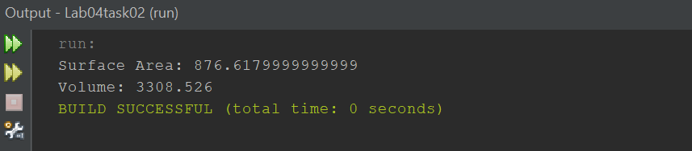
Task No 03: Use constructor overloading to initialize a rectangle of length 4 and breadth 5 for using custom parameters.
Code:
Main:
package lab04task03;

public class Lab04task03 {

public static void main(String[] args) {

Rectangle c1 = new Rectangle ();
Rectangle c2 = new Rectangle (7,4);

c1.Display();
c2.Display();
}
}
Employee:
package lab04task03;

public class Rectangle {

private int length;
private int breadth;

Rectangle (){

length = 6;
breadth = 2;
}
Rectangle (int L, int b){

length = L;
breadth = b;
}
public void Display() {

System.out.println("Length: " + length);
System.out.println("Breadth: " + breadth);
}
}
Output:
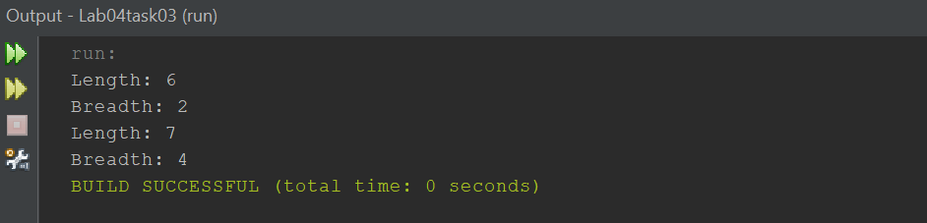
Task No 04: template
Code:
Output:

